**Faculty of Computers and Artificial intelligence**

**Cairo University**

**Simulation Project**

Submitted to:

Prof. Ayman Ghoneim

Prepared by:

|  |  |  |  |
| --- | --- | --- | --- |
| |  | | --- | | **Student name** | | **ID** | **Section** |
| Abdelrahman Mansour Mohamed | 20200295 | S1 |
| Sief Amr Mohamed | 20200242 | S2 |
| Mohamed Medhat Abdel Fattah | 20200476 | S2 |
| Abdelrahman Ehab Samir | 20200312 | S4 |

**Components**

**1.Problem Formulation ……………………………………………………………………… 3**

**2.Objectives: ……………………………………………………………………………………… 3**

**3.System Components: ……………………………………………………………………… 3**

**4.System Analysis: ……………………………………………………………………………… 3**

**5. Experimental design parameters: …………………………………………………… 5**

**6. Justification of Parameters: …………………………………………………………… 5**

**7. Result Analysis: ……………………………………………………………………………… 5**

**1. Problem Formulation:**

* Newspaper Seller wants to know the most profitable number of Newspaper to buy each day
* Meeting with Seller to understand what to simulate

**2. Objectives:**

* What are objectives of the seller:
* Reduce Overflow of Demands
* Reduce Salvages
* Maximize Profits

**3. System Components:**

Entity: Newspaper

Attribute: News

Activity: Reading News

Events: Demand

State Variables: Newsday Type, number of Newspaper bought

**4.System Analysis:**

**Calendar Table for Newsday type:-**

|  |  |  |  |
| --- | --- | --- | --- |
| **Newsday type** | **Probability** | **Cumulative Probability** | **Assigned Digits** |
| Excellent | 0.18 | 0.18 | 01 – 18 |
| Good | 0.42 | 0.60 | 19 – 60 |
| Fair | 0.32 | 0.92 | 61 – 92 |
| Poor | 0.08 | 1.00 | 93 – 00 |

|  |  |  |  |  |  |
| --- | --- | --- | --- | --- | --- |
| **Day** | **Assigned Digit** | **Newsday Type** | **Day** | **Assigned Digit** | **Newsday Type** |
| 1 | 72 | Fair | 6 | 34 | Good |
| 2 | 80 | Fair | 7 | 4 | Excellent |
| 3 | 43 | Good | 8 | 24 | Good |
| 4 | 74 | Fair | 9 | 96 | Poor |
| 5 | 88 | Fair | 10 | 64 | Fair |



**Calendar table For Demand probability**

|  |  |  |  |  |  |  |  |  |
| --- | --- | --- | --- | --- | --- | --- | --- | --- |
| **Demand** | **Probability** | | | | **Cumulative Probability** | | | |
| **Excellent** | **Good** | **Fair** | **Poor** | **Excellent** | **Good** | **Fair** | **Poor** |
| 40 | 0 | 0.06 | 0.15 | 0.42 | 0 | 0.06 | 0.15 | 0.42 |
| 50 | 0.07 | 0.09 | 0.22 | 0.28 | 0.07 | 0.15 | 0.37 | 0.70 |
| 60 | 008 | 0.16 | 0.28 | 0.14 | 0.15 | 0.31 | 0.65 | 0.84 |
| 70 | 0.12 | 0.19 | 0.18 | 0.10 | 0.27 | 0.50 | 0.83 | 0.94 |
| 80 | 0.13 | 0.28 | 0.10 | 0.05 | 0.40 | 0.78 | 0.93 | 0.99 |
| 90 | 0.22 | 0.12 | 0.05 | 0.01 | 0.62 | 0.90 | 0.98 | 1 |
| 100 | 0.23 | 0.07 | 0.02 | 0 | 0.85 | 0.97 | 1 | 0 |
| 110 | 0.08 | 0.03 | 0 | 0 | 0.93 | 1 | 0 | 0 |
| 120 | 0.07 | 0 | 0 | 0 | 1 | 0 | 0 | 0 |

|  |  |  |  |  |  |  |  |
| --- | --- | --- | --- | --- | --- | --- | --- |
| **Cumulative Probability** | | | | **Assigned Digits** | | | |
| **Excellent** | **Good** | **Fair** | **Poor** | **Excellent** | **Good** | **Fair** | **Poor** |
| 0 | 0.06 | 0.15 | 0.42 | 0 | 01 – 06 | 01 – 15 | 01 – 42 |
| 0.07 | 0.15 | 0.37 | 0.70 | 01 – 07 | 07 – 15 | 16 – 37 | 43 – 70 |
| 0.15 | 0.31 | 0.65 | 0.84 | 08 – 15 | 16 – 31 | 38 – 65 | 71 – 84 |
| 0.27 | 0.50 | 0.83 | 0.94 | 16 – 27 | 32 – 50 | 66 – 83 | 85 – 94 |
| 0.40 | 0.78 | 0.93 | 0.99 | 28 – 40 | 51 – 78 | 84 – 93 | 95 – 99 |
| 0.62 | 0.90 | 0.98 | 1 | 41 – 62 | 79 – 90 | 94 – 98 | 00 |
| 0.85 | 0.97 | 1 | 0 | 63 – 85 | 91 – 97 | 99 – 00 | 0 |
| 0.93 | 1 | 0 | 0 | 86 – 93 | 98 – 00 | 0 | 0 |
| 1 | 0 | 0 | 0 | 94 – 00 | 0 | 0 | 0 |

|  |  |  |  |  |  |  |  |
| --- | --- | --- | --- | --- | --- | --- | --- |
| **Day** | **Newsday Type** | **Assigned Digit** | **Demand** | **Day** | **Newsday Type** | **Assigned Digit** | **Demand** |
| 1 | Fair | 36 | 50 | 6 | Good | 82 | 70 |
| 2 | Fair | 34 | 50 | 7 | Excellent | 90 | 100 |
| 3 | Good | 7 | 50 | 8 | Good | 94 | 90 |
| 4 | Fair | 29 | 50 | 9 | Poor | 46 | 50 |
| 5 | Fair | 51 | 60 | 10 | Fair | 27 | 50 |



**Simulation table for purchase of 80 newspaper**

|  |  |  |  |  |  |  |
| --- | --- | --- | --- | --- | --- | --- |
| **Day** | **Newsday Type** | **Demand** | **Revenue** | **Loss from Overflow** | **Salvage** | **Daily Profit** |
| 1 | Fair | 50 | $35 |  | $4.5 | -$0.5 |
| 2 | Fair | 50 | $35 | - | $4.5 | -$0.5 |
| 3 | Good | 50 | $35 | - | $4.5 | -$0.5 |
| 4 | Fair | 50 | $35 | - | $4.5 | -$0.5 |
| 5 | Fair | 60 | $42 | - | $3 | $5 |
| 6 | Good | 70 | $49 | - | $1.5 | $10.5 |
| 7 | Excellent | 100 | $56 | $3.4 | - | $10.9 |
| 8 | Good | 90 | $56 | $1.7 | - | $12.6 |
| 9 | Poor | 50 | $35 | - | $4.5 | -$0.5 |
| 10 | Fair | 50 | $35 | - | $4.5 | -$0.5 |
| Total |  |  | $413 | $5.1 | $31.5 | $36 |

**Simulation table for purchase of 60 newspaper**

|  |  |  |  |  |  |  |
| --- | --- | --- | --- | --- | --- | --- |
| **Day** | **Newsday Type** | **Demand** | **Revenue** | **Loss from Overflow** | **Salvage** | **Daily Profit** |
| 1 | Fair | 50 | $35 |  | $1.5 | $6.5 |
| 2 | Fair | 50 | $35 | - | $1.5 | $6.5 |
| 3 | Good | 50 | $35 | - | $1.5 | $6.5 |
| 4 | Fair | 50 | $35 | - | $1.5 | $6.5 |
| 5 | Fair | 60 | $42 | - | - | $12 |
| 6 | Good | 70 | $42 | $1.7 | - | $10.3 |
| 7 | Excellent | 100 | $42 | $5.1 | - | $5.2 |
| 8 | Good | 90 | $42 | $3.4 | - | $6.9 |
| 9 | Poor | 50 | $35 | - | $1.5 | $6.5 |
| 10 | Fair | 50 | $35 | - | $1.5 | $6.5 |
| Total |  |  | $378 | $10.2 | $10.5 | $73.4 |

**5. Experimental design parameters:**

* We have two types of experimental parameters:-
* Probalistic parameters such as: Newsday Type, Demand
* Controllable parameters such as: Bundle size, selling price, salvage price.
* We are going to use both 60 & 80 Newspaper bundle size .
* We are going to increase and decrease salvage price

**6.Justification of Parameters:**

* 60, 70 & 80 Newspaper have higher demand rate across all the Newsday types.
* We can only understand how salvage prices affect the system by changing them.

**7. Result Analysis:**

**Histogram of 200 Trials with 80 Newspaper each for 10 days**

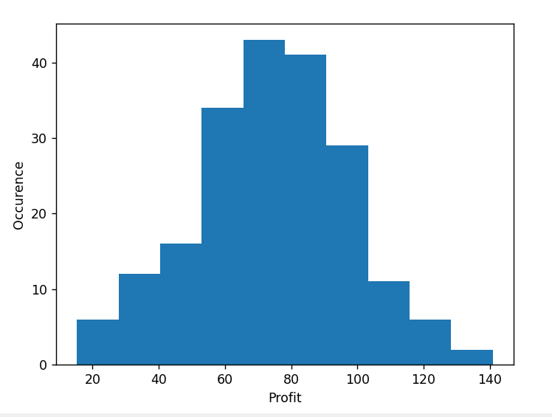

**Histogram of 200 Trials with 60 Newspaper each for 10 days**

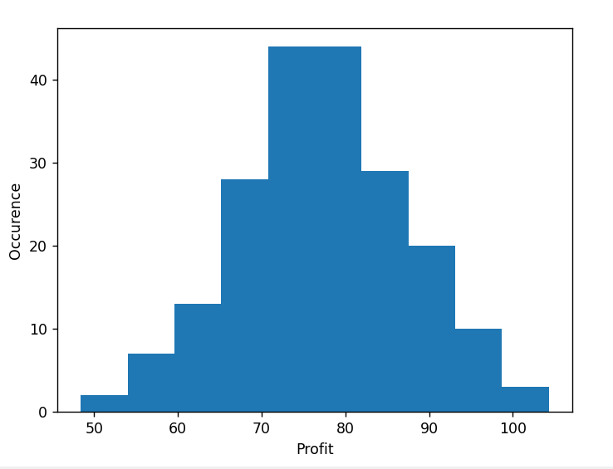

**Q.1**

**Determine the optimal number of papers the seller should purchase to increase his**

**profit.**

* **80 Newspaper is a more optimal answer**

**Histogram of 200 Trials with 25 Cents as salvage price each for 10 days**

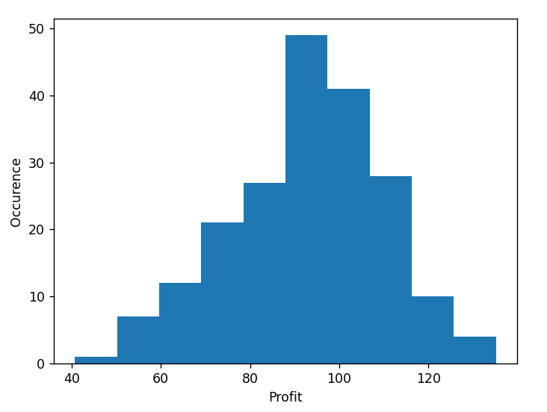

**Histogram of 200 Trials with 5 Cents as salvage price each for 10 days**

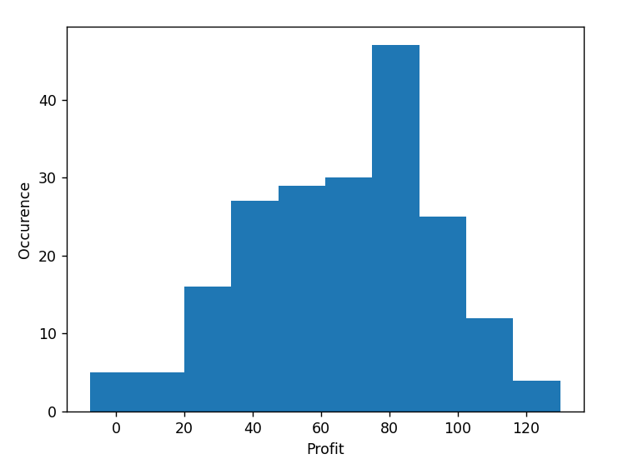

**Q.2** **How does the price of selling the newspaper and of selling the unsold newspapers as a scrap affect your answer (the optimal number to purchase) in the previous question (1)?**

* It helps decrease the losses when the demand is less than the number of provided Newspaper
* If Salvage of left Newspaper was not possible it would be more optimal to buy less Newspaper

**Histogram of 200 Trials with 70 Newspaper each for 10 days**

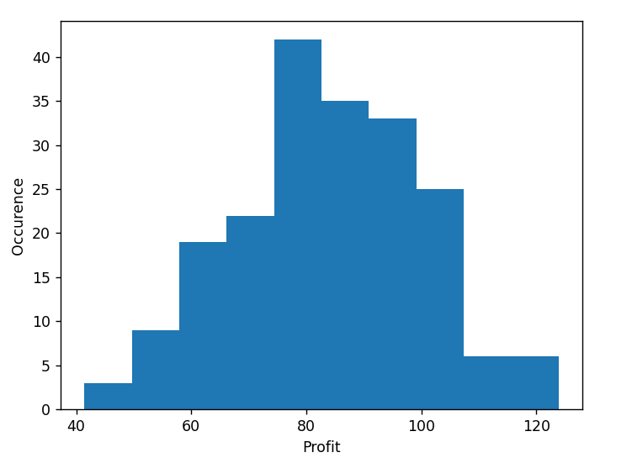

**Q.3** **How does the size of bundle used to purchase newspapers affect your answer (the optimal number to purchase) in the previous question (1)?**

* 70 Newspaper is a more optimal solution than 80 Newspaper , So the bundle size is stopping the buyer from getting the most optimal solution